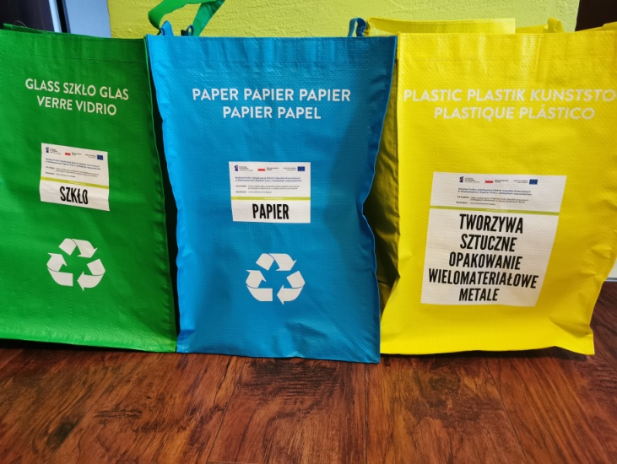
I decided to check how many rubbish is collected in home during three days. I divided the garbage into three bags: to green one I threw out the glass, to blue one I threw away papers and to the yellow bag I threw away all plastic and metal. Others rubbish I threw out into normal bin, because it stinks.

After three days in the green bag I found two bottles. The blue bag was half-full of papers. I was really shocked when I saw the yellow bag. Plastic garbage barely fit in it.
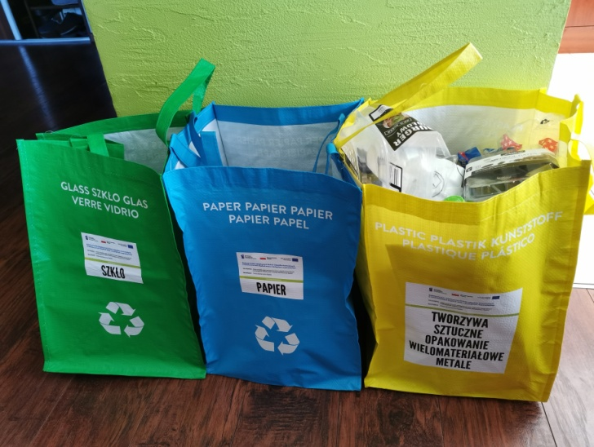

Until today I tried to segregate rubbish but now I see how important and necessary it is. I have one conclusion: people produce and use way too much plastic. We need to reduce the prodcution, otherwise the plastic could overwhelm us one day.

