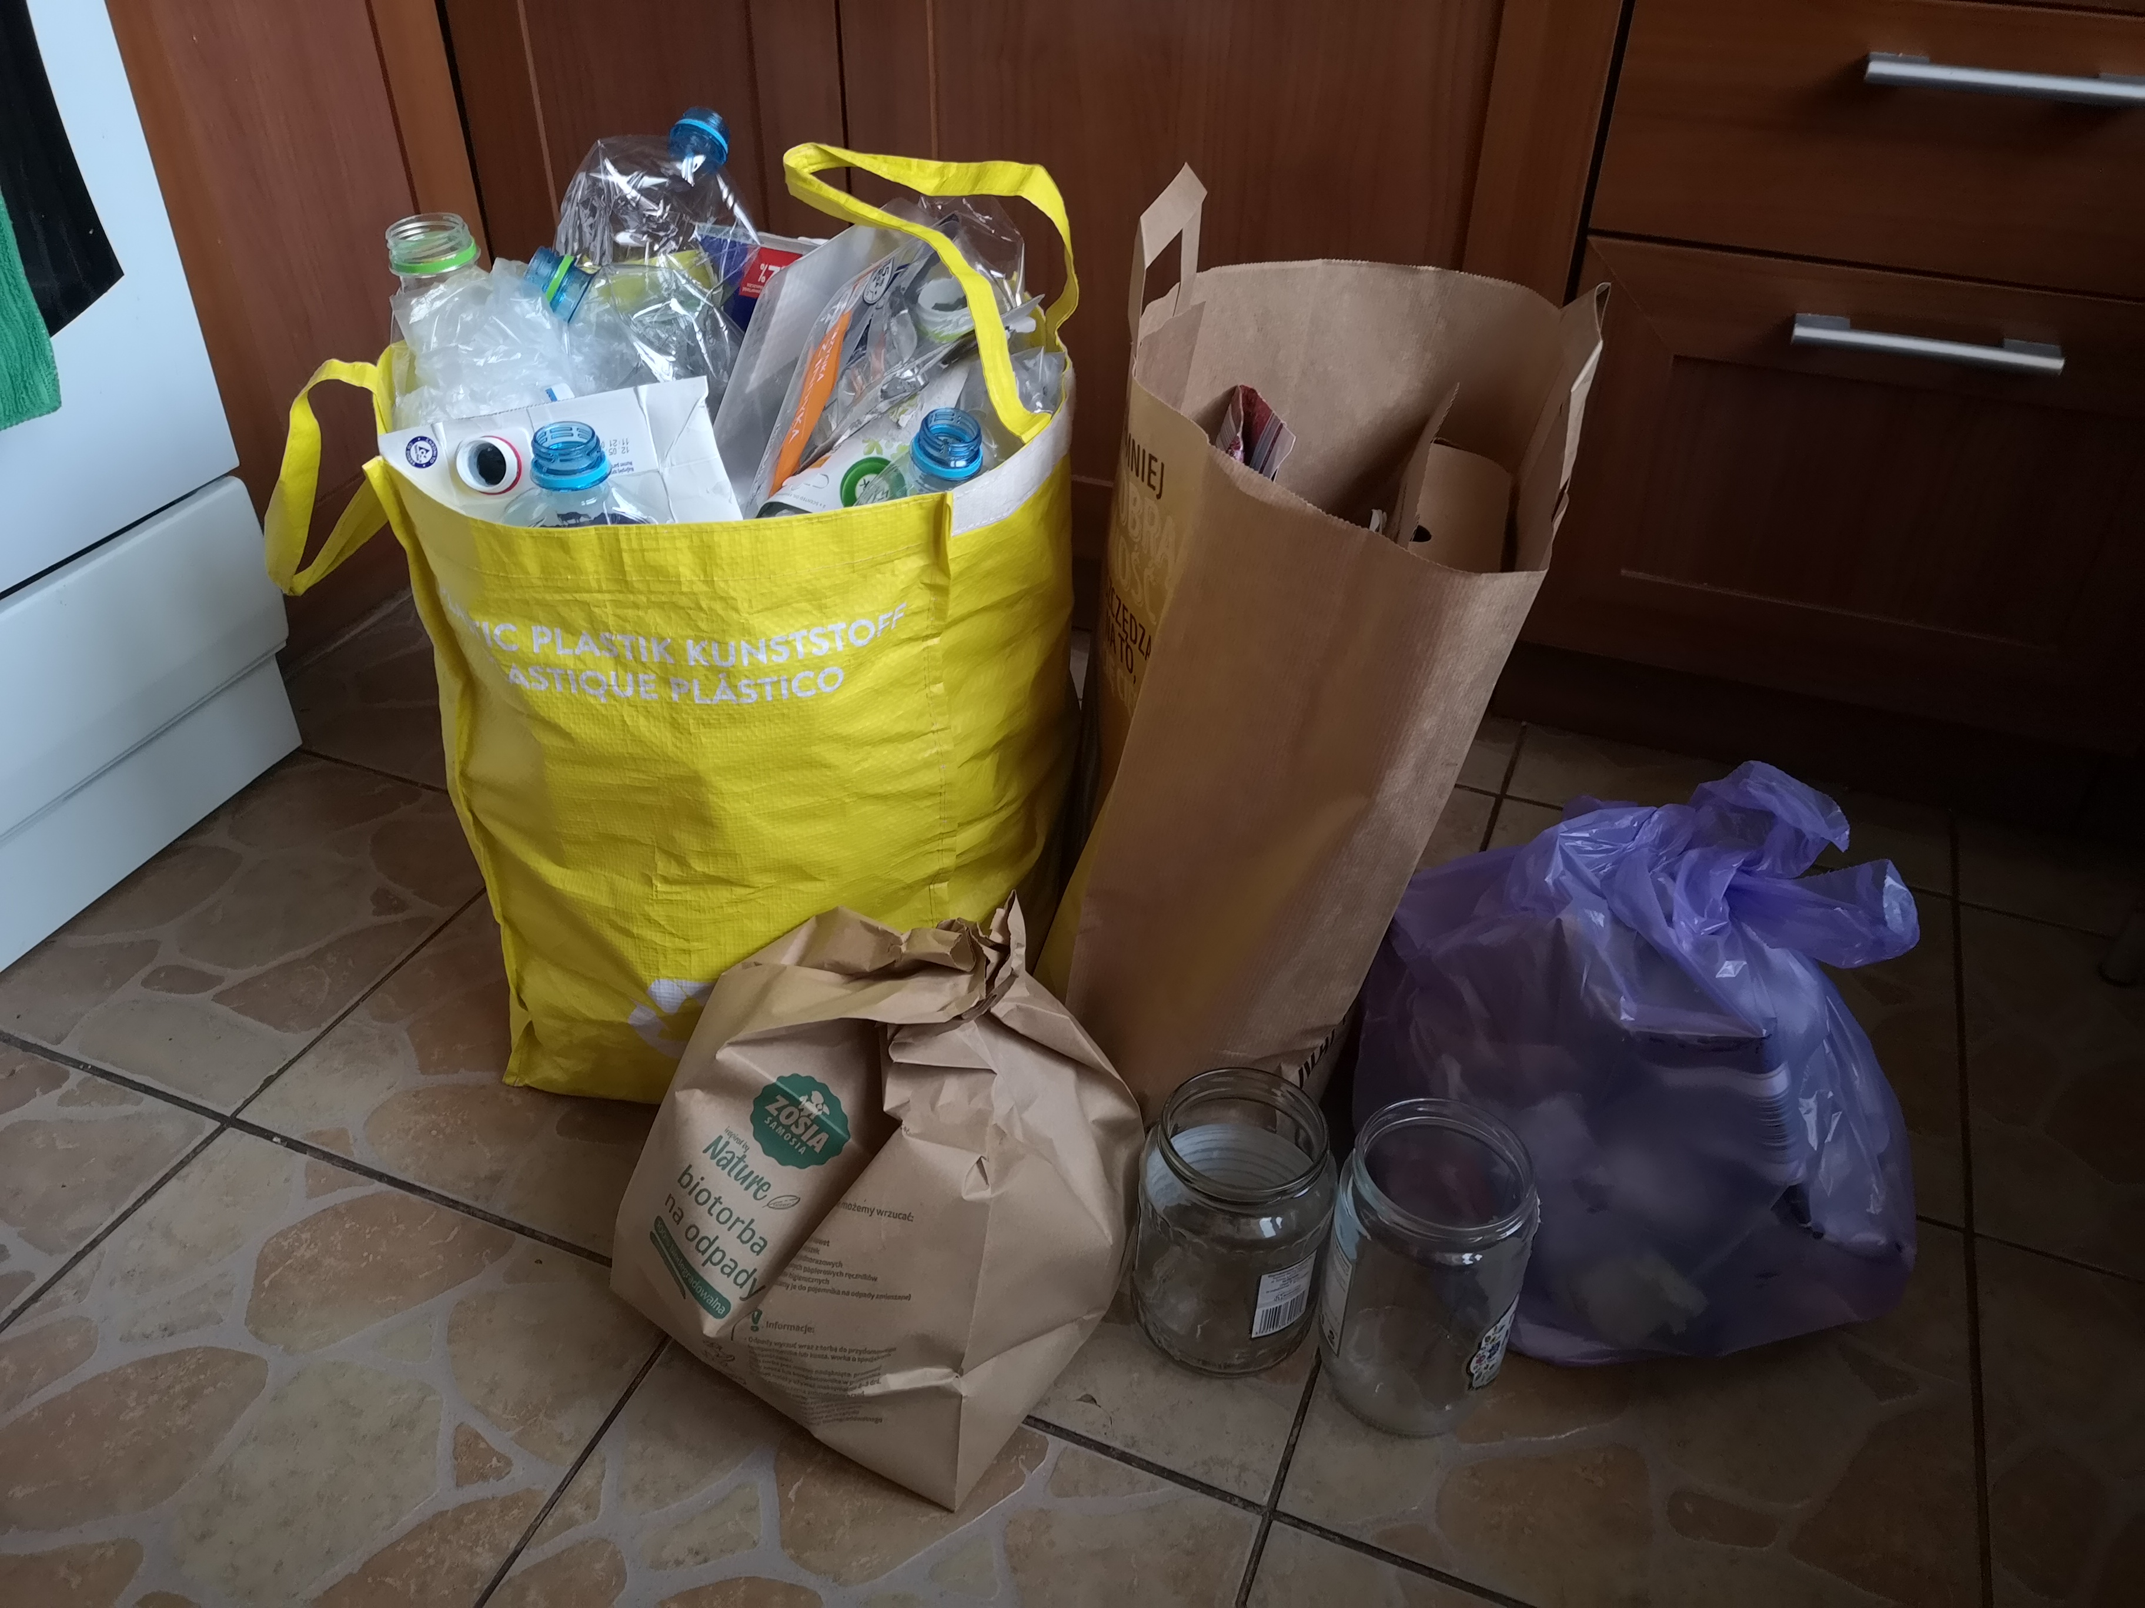

Sorting garbage

My family has been segregating rubbish for several years. We divide them into: plastics, papers, glasses, bio-waste and mixed waste. Plastic is always the most abundant and glass the least. I really like to separate rubbish because it is not only good for the environment, but it can also be fun.


