Jakub Jaworski
Klasa V B

„The clean up day”

I carried out the observation for 3 days from Sunday, November 15 at 16:00 to Wednesday 18 November at 4:00 p.m.

We collected the most plastic garbage: packaging, bags, water and drink bottles, cans.
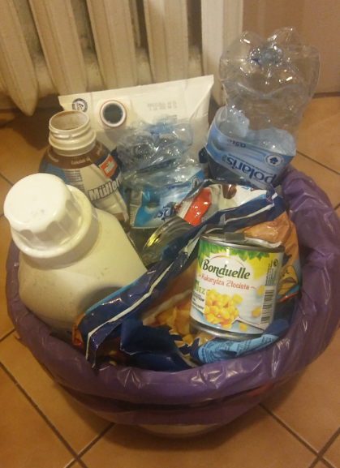

Paper trash is in second place: magazines, packaging, boxes, cards.
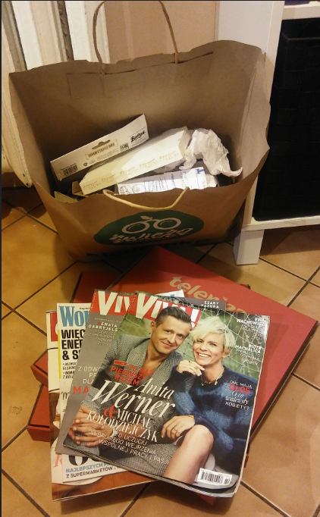

There was the least amount of ordinary rubbish and there was no glass rubbish at all.

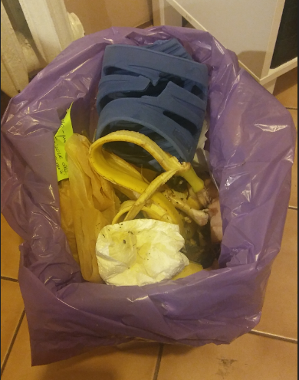

We have always sorted garbage in my house. We go shopping with linen and reusable bags.

For as long as I can remember, we have the most plastic garbage. Among them, the most are water and drink bottles. I think we need to consider whether instead of, for example, buying bottled water, it would be better to install a water filter at home or buy a jug with a filter. Separately, we collect plastic stoppers from bottles, they can be returned to school for a concrete purpose.

We used to take paper trash to school and put it on waste paper. Since the school does not collect waste paper, we pass the magazines to grandma and aunt for reading and throw the rest of the paper trash into the blue container.

We do not have a lot of ordinary rubbish, because we try not to waste food on a daily basis and therefore we produce little waste. We do not throw toys, games and books into the garbage, but hand them over to school or for a family member. If they are in good condition, I donate my clothes to younger children.

I believe that we are quite good at segregating rubbish at home, but we still have to try to reduce their amount.

