Croatia | Cyprus | Poland | Slovakia | Czech Republic
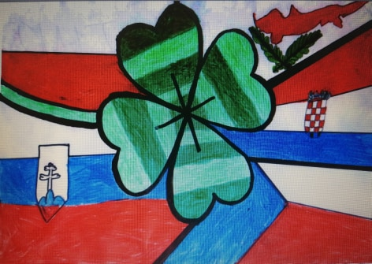 |  | 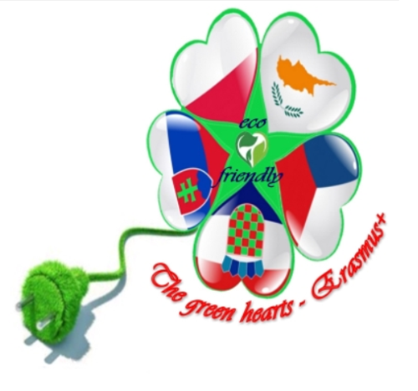
Cyprus-15 | Croatia-15 | Croatia-20 | Croatia-10 | Croatia-5
Poland-10 | Poland- 20 | Cyprus-20 | Cyprus-10 | Cyprus-5
Slovakia-5 | Slovakia-20 | Slovakia-15 | Poland-15 | Poland-5
Czech Republic- 10 | Czech Republic-20 | Czech Republic-5 | Czech Republic-15 | Slovakia-10
Total sum: 40 points | Total sum: 75 points | Total sum: 60 points | Total sum: 50 points | Total sum: 25 points

THE WINNING LOGO IS…… CYPRUS!!!! CONGRATULATIONS!

